**TASK TWO**

1. Change your username, password & hostname in Kali Linux from the terminal

a. Change username

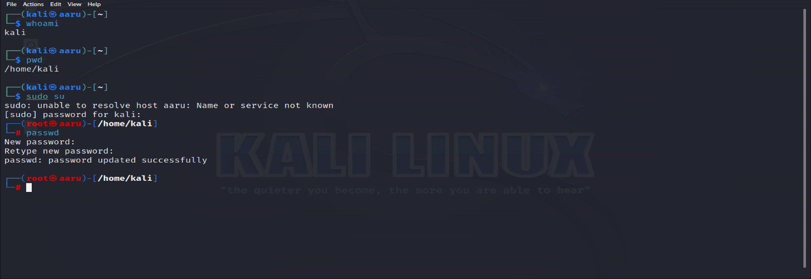

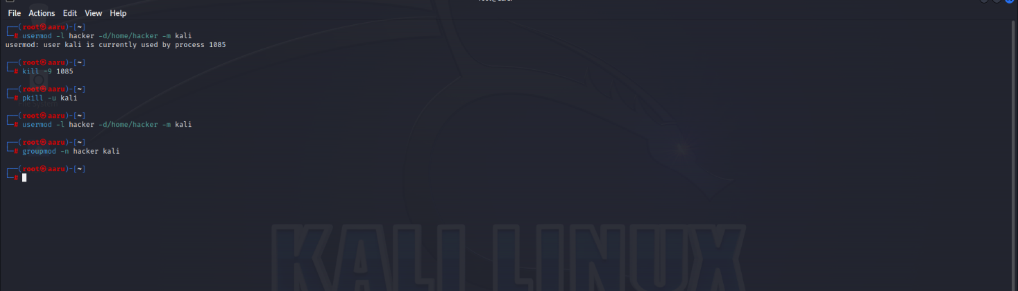

b. Change Password

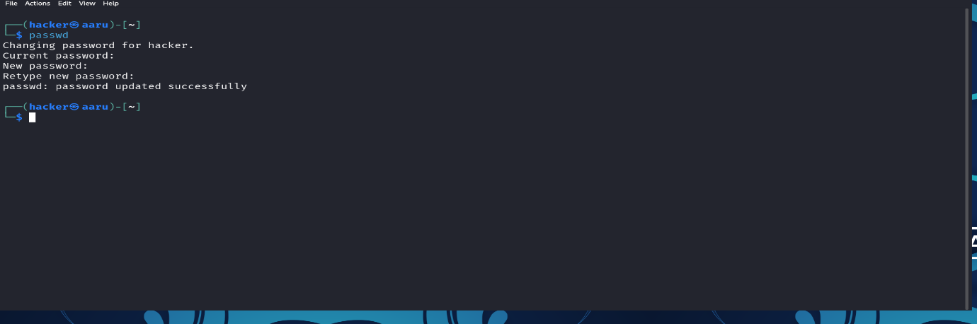

c. Change Hostname



1. Find your public IP, private IP & mac address from command line

